When Does Scaling Overcome Simplicity Bias
  - An optimization controlled synthetic study of competing predictive features
Research proposal with preliminary experimental results

1 Introduction
When several features predict the same target, a neural network may rely primarily on the simpler signal. The scientific question is whether this preference follows from feature complexity itself or depends on how the inputs and training updates are parameterized. This study tests that distinction using a small synthetic task with one linearly separable feature and one nonlinear XNOR feature.
We vary only the positive numerical scale of the complex feature, preserving its label information and nonlinear structure. We then match initial network functions and compensate SGD updates to separate two effects of scaling. Preliminary runs show that larger scales can reverse conflict preference, while compensated SGD restores the unit scale reference behavior. The aim is to identify a boundary condition for simplicity preference in this setting, rather than claim a general refutation.

2 Literature Review
Shah et al. (2020) study simplicity bias using piecewise linear and image based datasets containing predictive features of different complexity. Their theoretical and empirical results show that SGD trained networks can rely exclusively on simple features, even when more complex signals are useful or more predictive. This motivates testing which aspects of the training setup make such preference possible [1].
Morwani et al. (2023) define simplicity bias through dependence on a low dimensional input projection and analyze one hidden layer networks in an infinite width regime. Their results connect linearly separable data with reliance on the separable subspace. Our width 32 network and finite training budget differ from that regime, so a preference reversal here would not by itself contradict their theorem [2].
Rahaman et al. (2019) study spectral bias, in which lower frequency functions are learned faster, and show that data manifold geometry can affect learning. Frequency, dimensionality, and linear separability are distinct notions of simplicity. The present study uses linear separability as its operational definition and does not directly test spectral bias [3].
The question pursued here is narrower than universality: does the observed preference survive a change in numerical scale when predictive information and the XNOR rule remain fixed?

3 Research Question
Holding target information and nonlinear structure fixed, does positive scaling of a complex predictive feature alter a small ReLU MLP’s learned feature preference, and can that alteration be explained by SGD parameterization?
Preference is operationalized as agreement with the complex rule on four balanced contradictory inputs. A score above 0.5 indicates complex rule preference on these probes; it does not uniquely identify reliance on ordinary training inputs.

4 Hypothesis and Null Hypothesis
H₁: Increasing complex feature scale α increases complex rule conflict agreement under fixed learning rate SGD, potentially moving it from below to above 0.5. The proposed reason is that scale changes optimization accessibility, even though both feature groups remain perfectly predictive.
H₀: Under the specified data, architecture, optimizer, and training budget, increasing α produces no systematic change in complex rule conflict agreement across paired initialization seeds.
Mechanistic prediction: with matched initial functions, scaling changes the effective complex weight update by α². Dividing the complex column learning rate by α² should reproduce the reference trajectory under plain SGD. This is an algebraic sanity control under stated assumptions, rather than a separate statistical hypothesis about feature complexity.

5 Proposed Experiment Suite

Dataset and definition of simplicity
For each example, sample Y uniformly from {0, 1} and independently sample U uniformly from {−1, +1}. Define T = 2Y − 1, the simple feature Xₛ = T, and the complex pair X꜀ = (U, UT). For α > 0, the network receives:
$$Xα = [T, αU, αUT]$$
The simple rule is Y = 1[Xₛ > 0]. The complex rule is Y = 1[X꜀₁X꜀₂ > 0], an equality of signs or XNOR pattern. The network receives the coordinates, not their product. A linear classifier can solve the simple rule but cannot separate the four XNOR configurations. Positive scaling preserves the product sign because (αU)(αUT) = α²T.
Y | U | Unscaled input | Complex product
0 | −1 | [−1, −1, +1] | −1
0 | +1 | [−1, +1, −1] | −1
1 | −1 | [+1, −1, −1] | +1
1 | +1 | [+1, +1, +1] | +1

There are four distinct input prototypes. The generating population is balanced, but the current random sample is not exactly balanced. Both groups recover every sampled label without error. Repeated samples measure learning of this toy function, not generalization to unseen feature structures.

Model and training procedure
Use Linear(3, 32) → ReLU → Linear(32, 1), binary cross entropy with logits, and full batch plain SGD. Fix 1,024 samples, data seed 11, learning rate 0.03, and 500 updates. Pair initialization seeds 42–46 across scales α ∈ {0.1, 0.5, 1, 2, 5, 10}. Keep momentum, weight decay, and gradient clipping disabled. Log measurements at step 0 and every 25 updates through step 500.
Each update computes first layer preactivations, applies ReLU, produces a logit, evaluates mean batch loss, backpropagates gradients, applies any specified compensation, and then takes an SGD step. Sigmoid probabilities are used for evaluation; BCEWithLogitsLoss receives the raw logits.

Experimental conditions
Feature only capability baseline. Train separate Linear(1, 32) and Linear(2, 32) models on the simple and complex groups at α = 1. Match the five seeds, data, optimizer, learning rate, and 500 update budget. This tests whether each rule can be learned separately under the reference training settings.
Ordinary scaling. Multiply the two complex input coordinates by α. Reuse the same numerical model initialization and underlying data across scales. This measures the total scaling effect, including changes in initial predictions and activation gates.
Inverse initialization. Scale the complex inputs and divide only the corresponding first layer weight columns by α. Keep other parameters and the global learning rate unchanged. This matches the initial function but leaves subsequent SGD dynamics free to diverge.
Compensated SGD. Combine inverse initialization with division of the complex column gradients by α² after backpropagation and before the optimizer step. This is equivalent to learning rate 0.03/α² for those columns. All other parameters retain learning rate 0.03.
Standardization control. Standardize each input coordinate using its own mean and standard deviation. Positive scale cancels in exact arithmetic. This separate input invariance check establishes that such preprocessing would remove the intended treatment; it is not applied in the primary sweep.

Evaluation and analysis
Primary metric: evaluate [tₛ, αu, αu(−tₛ)] for all four combinations of tₛ and u in {−1, +1}. Score the fraction of predictions agreeing with the complex implied class. Values occur in increments of 0.25 for an individual model.
Secondary metrics: flip the simple coordinate or negate one complex coordinate and measure the hard prediction flip rate and mean absolute sigmoid probability change. Also report training accuracy, BCE loss, and initial and final numerical equivalence checks. These probes are outside the joint training distribution.
Compare every scale with α = 1 within the same seed. Report individual values, mean paired changes, and sample standard deviation across seeds. The current results are descriptive; any confirmatory extension should define uncertainty analysis and decision criteria before new runs. Group permutation drops are a proposed additional probe, not an outcome recorded by the current trained runner.

Understanding the complex rule and evaluation

What the complex rule means
The complex rule compares the signs of two coordinates. If both signs are the same, predict class 1; if they differ, predict class 0. Thus (+1, +1) and (−1, −1) mean class 1, whereas (+1, −1) and (−1, +1) mean class 0. This is XNOR, or equality of signs. We call it complex relative to the simple rule because no single straight line separates these two pairs of corners in the complex feature plane.
The product is a convenient way to describe the rule: same signs give a positive product, different signs give a negative product. Our construction uses (U, UT), so U(UT) = U²T = T. At α = 5, (+5, +5) still means class 1 and (+5, −5) still means class 0. Scaling changes the magnitudes, not the rule. The MLP receives both coordinates and must learn this relationship; we do not supply their product as an input.

First measure conflict agreement
Ordinary accuracy cannot distinguish the rules because both predict the correct label on every training example. We therefore deliberately make them disagree. For example, [1, 5, −5] has a simple sign suggesting class 1 and a complex pair suggesting class 0. If the model predicts 0, this probe counts as agreement with the complex rule; if it predicts 1, it does not.
$$Conflict agreement = number of probes following the complex rule / 4$$
We test all four combinations of simple sign and nuisance sign, giving both conflict directions equal weight. A score of 1 means all probes follow the complex rule; 0 means all follow the simple rule. A score of 0.5 means two of four probes follow each rule, not necessarily equal use of both features. These are contradictory diagnostic inputs, so this score is not test accuracy against a true label.

Second measure counterfactual sensitivity
Start from an ordinary input such as [1, 5, 5]. A simple intervention makes [−1, 5, 5]; a complex intervention makes [1, 5, −5]. Change one group at a time and compare the prediction before and after. Negating one complex coordinate reverses its implied class; negating both would preserve the product sign. We report two outputs for each intervention:
Hard prediction flip rate is the fraction of sampled examples whose predicted class changes. A rate of 1 means every prediction flips; 0 means none do. Classes use probability at least 0.5 for class 1. This measures crossings of the decision threshold, not smaller changes in confidence.
Mean absolute probability change averages |p after − p before|, where p is the sigmoid probability of class 1. A change from 0.9 to 0.6 contributes 0.3 but no hard flip. A change from 0.9 to 0.4 contributes 0.5 and one hard flip. This distinguishes confidence shifts from class changes; neither is a measure of accuracy or calibration.
Sensitivity means are weighted by the 1,024 sampled examples, whereas conflict agreement weights four probes equally. The interventions reuse those same four contradictory prototypes, so the hard flip results are closely related to conflict agreement. All describe behavior on inputs outside the training distribution, not uniquely identified causal reliance or internal representations.

6 Controls and Confounding Variables
We use two controls because scaling can change both the network’s starting predictions and how it learns. A shift toward the complex rule might therefore reflect initialization or optimization rather than an intrinsic preference for complexity. We remove these explanations in stages.

Why we divide the initial weights by alpha
A first layer neuron receives the complex feature through a weighted product. For one coordinate, the reference contribution is wx. Replacing x with αx while keeping w fixed changes this contribution to αwx. To preserve the starting contribution, we need a new weight wα satisfying wα(αx) = wx. Solving for that weight gives wα = w/α.
$$(w / α)(αx) = wx$$
For example, if x = 2 and w = 0.4, the contribution is 0.8. With α = 5, the input becomes 10 and the weight becomes 0.08; their product is still 0.8. Apply this cancellation to both complex columns of the first layer, keeping all other weights and biases unchanged:
$$W꜀⁽α⁾ = W꜀⁽¹⁾ / α$$
Every hidden preactivation then matches the reference. The ReLU gates, output logits, and loss also match before training. This control asks whether a preference shift can occur even when the networks start by computing the same function. It does not yet make their learning updates equivalent.

Where the two factors of alpha come from
Define V꜀ = αW꜀⁽α⁾, the effective weights multiplying the original unscaled complex input. Write g for the reference loss gradient with respect to these effective weights at a matched state. The chain rule gives:
$$∇W꜀ L = αg$$
The first factor of α comes from the scaled input in backpropagation. Equivalently, with G = ∂L/∂Z₁, the reference gradient is g = GᵀX꜀ and the scaled gradient is Gᵀ(αX꜀) = αg. G includes the loss derivative, batch averaging, and ReLU gates; it matches when the effective parameters match.
Ordinary SGD changes the stored weight by ΔW꜀ = −ηαg. To find the change in its contribution to the original input, multiply that update by α again:
$$ΔV꜀ = αΔW꜀ = α(-ηαg) = -ηα²g$$
The second factor of α comes from converting the stored weight update into an effective weight update. Thus, at a matched state, α = 5 gives a gradient five times as large and an effective update 25 times as large. Once uncompensated models diverge, their gradients need not retain this simple ratio.

Why compensated SGD divides by alpha squared
The reference SGD step is ΔV꜀ = −ηg. We therefore choose a complex column learning rate η꜀ that cancels both scale factors:
$$η꜀ = η / α²$$
$$ΔV꜀ = α[-(η / α²)(αg)] = -ηg$$
For α = 5 and η = 0.03, this gives η꜀ = 0.0012. Multiplying the fivefold gradient by 0.0012 gives a stored weight update of −0.006g. Its effective update is five times that, or −0.03g, exactly the reference step.
In code, we keep the optimizer learning rate at 0.03 and divide only fc1.weight.grad[:, 1:3] by α² after backward() and before opt.step(). This produces the same update as the reduced complex column learning rate. The simple column, both layer biases, and output weights retain the original learning rate because their parameterization was not scaled.
Inverse initialization supplies the matched starting state. Compensation then preserves matched effective parameters after one step. Repeating this argument explains why the entire function trajectory should match in exact arithmetic, rather than only the final accuracy. This is why compensation must accompany inverse initialization for the reference comparison.

Assumptions and what the controls establish
The derivation applies to our plain SGD setup with identical data and update order, and no momentum, weight decay, or gradient clipping. Floating point rounding can produce small discrepancies. The α² result describes effective weight updates, not an α² faster decrease in loss. It also cannot be assumed for ordinary scaling when initial functions differ.
We also hold label information, sampled examples, initialization seeds, and training budget fixed within comparisons. Feature only baselines test learnability. Dimensionality remains confounded with nonlinear structure because the simple group has one coordinate and the complex group has two.

7 Expected Outcomes and Interpretation
Possible outcome | Interpretation
Simple preference at every scale | Preference persists in this setting if complex only learning succeeds.
Complex preference at larger scales | Numerical scale qualifies an unconditional simplicity preference claim.
Inverse initialization removes the shift | Changes to the initial function may account for the ordinary scaling result.
Shift persists with inverse initialization | Different initial functions are not necessary for the shift.
Compensated SGD matches the reference | Consistent with the effective SGD update explanation under the control assumptions.
Compensation fails or XOR baseline fails | Check implementation or learnability before interpreting feature preference.

8 Optional Experimental Results

Methodology and baseline outcomes
The completed primary sweep contains 90 runs: three conditions × six scales × five seeds. The training history contains 1,890 checkpoints. All runs use the configuration in Section 5 and reach 100% final training accuracy. No separate held out accuracy is reported.
The matched budget feature only baseline contains ten additional runs at α = 1. Both simple only and complex only models reach 100% training accuracy for every seed with learning rate 0.03 and 500 updates. Mean final BCE is 0.0105 for simple only and 0.0535 for complex only. This reduces the concern that XOR is unlearnable within the reference budget, while leaving differences in joint optimization and confidence unresolved.

Conflict preference across scales
α | Ordinary | Inverse init | Compensated SGD
0.1 | 0.00 | 0.00 | 0.00
0.5 | 0.00 | 0.00 | 0.00
1 | 0.00 | 0.00 | 0.00
2 | 0.85 | 0.05 | 0.00
5 | 1.00 | 0.95 | 0.00
10 | 1.00 | 1.00 | 0.00

Table 1. Mean final complex rule conflict agreement across five seeds. Zero favors the simple rule; one favors the complex rule on all four contradictory probes.
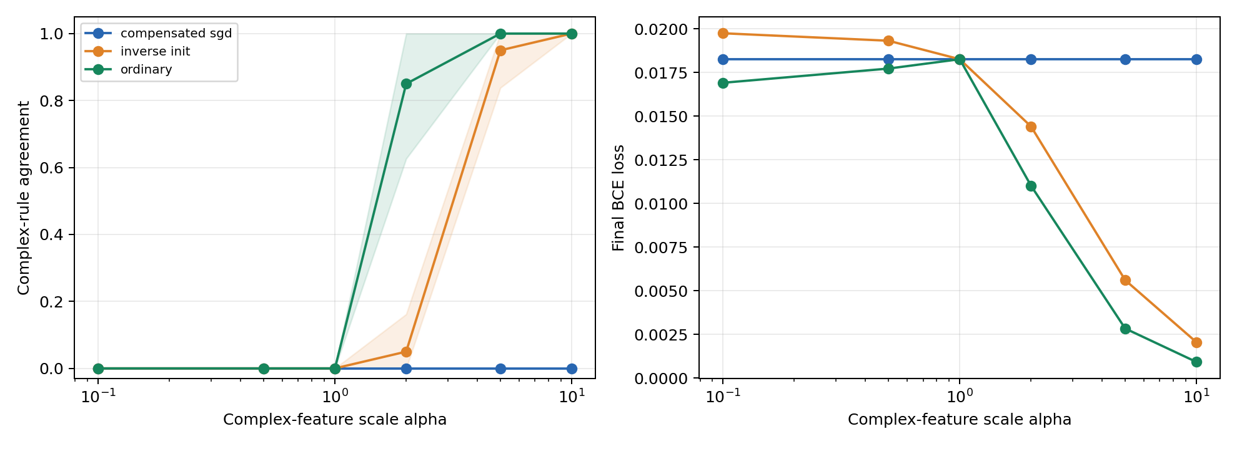
Figure 1. Final conflict agreement and training BCE versus complex feature scale. Shading shows one sample standard deviation across seeds, not a confidence interval.
Ordinary scaling reaches mean agreement 0.85 at α = 2 and 1.00 at α = 5 and 10. Inverse initialization delays the transition to 0.05 at α = 2 and 0.95 at α = 5, reaching 1.00 at α = 10. Compensated SGD remains at 0.00. At α = 5, all five ordinary runs favor the complex rule on every conflict probe; inverse initialization gives four scores of 1.00 and one of 0.75.

Counterfactual sensitivity and numerical controls
The current CSVs include the numerical counterfactual measurements. At α = 5, the means across seeds are:
Condition | Hard flip rates  simple / complex | Mean absolute probability change  simple / complex
Ordinary | 0.000 / 1.000 | 0.008 / 0.987
Inverse init | 0.050 / 0.951 | 0.167 / 0.822
Compensated | 1.000 / 0.000 | 0.911 / 0.053

Table 2. Final counterfactual sensitivity at α = 5. Hard flips compare predicted classes; probability changes compare sigmoid outputs before and after intervention.
Without compensation, larger scales increase sensitivity to the complex intervention and reduce sensitivity to the simple intervention. The compensated condition matches the unit scale reference: mean simple probability change is approximately 0.911 and mean complex probability change is 0.053 across scales.
For inverse initialization, the largest recorded initial preactivation mismatch is 2.38 × 10⁻⁷, initial logit mismatch 5.96 × 10⁻⁸, and gradient scaling mismatch 1.19 × 10⁻⁷. The maximum compensated final logit difference from the unit scale reference is 1.19 × 10⁻⁶. These values are consistent with numerical rounding.

Analysis
The shift survives matched initial functions, so changed initial predictions alone are insufficient to explain it. Compensation restores reference behavior as the reparameterization equations predict. Together, the results support an optimization based explanation within this setup. Equal training accuracy across conditions shows why that metric alone cannot identify preference.
The hard flip metrics reuse the same four contradictory prototypes as conflict agreement. With balanced prototypes and perfect original predictions, complex flip rate equals conflict agreement and simple flip rate equals its complement. Sample imbalance explains small numerical differences. These metrics are related behavioral views, not independent corroborating experiments.

Counterfactual sensitivity across feature scales
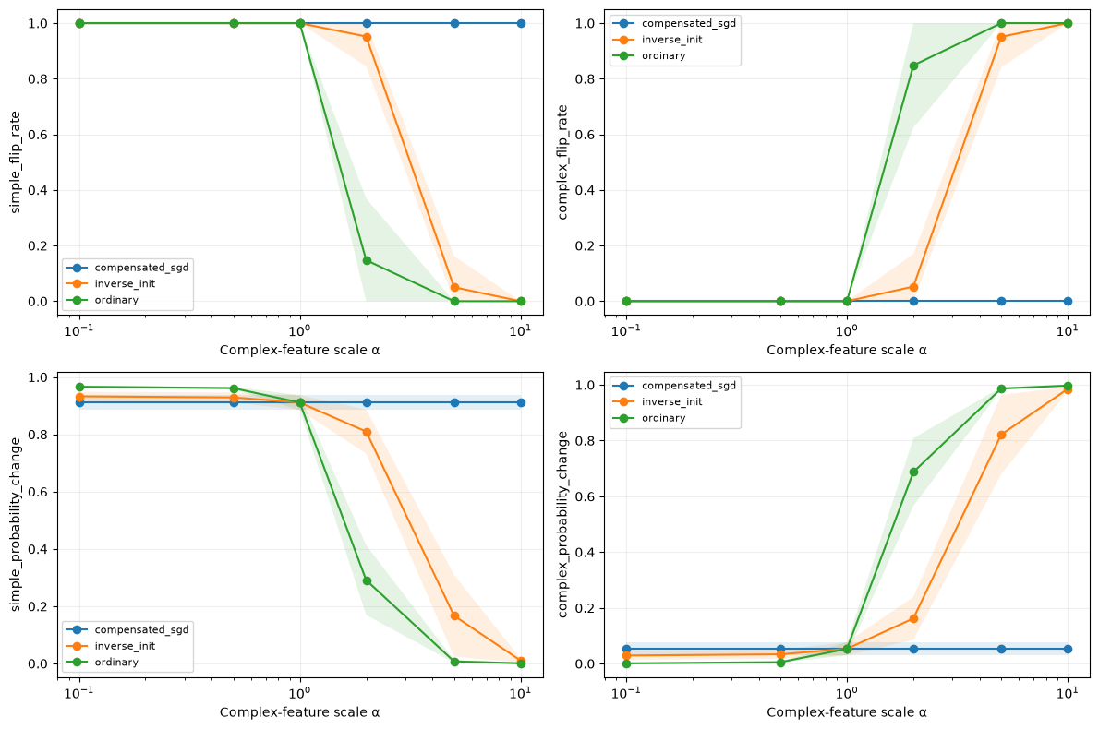
Figure 2. Final counterfactual sensitivity across complex feature scales, from Notebook 09. Top row: simple and complex hard prediction flip rates. Bottom row: mean absolute probability changes for the same interventions. Lines are means over five initialization seeds; shading is one sample standard deviation, clipped to [0, 1], not a confidence interval. The horizontal axis is logarithmic.
Read the left panels together: falling values mean predictions become less sensitive to changing the simple sign. Read the right panels together: rising values mean predictions become more sensitive to reversing the complex rule. The upper panels show changes of predicted class; the lower panels show changes of probability, including those that do not cross the classification threshold.
The ordinary condition changes most strongly between α = 1 and 2. The inverse condition makes its largest change between α = 2 and 5. The compensated condition remains nearly horizontal in every panel. The shaded bands are widest around the transitions, where initialization seeds differ most. These curves describe the tested scale values; connecting lines do not establish a precise continuous transition threshold.

Detailed interpretation of prediction results

What the conflict test establishes
The unit scale models favor the simple rule on all conflict probes after training. Under ordinary scaling, mean complex agreement rises from 0 at α = 1 to 0.85 at α = 2 and 1.00 at α = 5. Because labels, underlying samples, architecture, and update budget are unchanged, linear separability alone cannot explain preference across these runs. Numerical scale is a boundary condition for the observed simple preference in this finite training regime.
The reversal is not only an averaging effect. At α = 2, the five ordinary scores are 1.00, 1.00, 1.00, 0.75, and 0.50, so one seed is tied rather than complex dominant. At α = 5, every ordinary score is 1.00. Inverse initialization gives four scores of 1.00 and one of 0.75 at that scale; every tested seed still exceeds 0.5. Thus the complex preference survives matched initial functions in all five seeds, while its precise onset varies.
Initialization nevertheless affects the transition. At α = 2, ordinary and inverse mean agreement are 0.85 and 0.05, a paired mean difference of 0.80. Matching the initial function therefore changes the finite budget outcome at moderate scale, but does not prevent reversal at larger scales. This comparison does not uniquely attribute the difference to ReLU gates, since inverse initialization also changes initial weights and parameter norms.

Preference changes after training accuracy saturates
SGD step | Ordinary | Inverse init | Compensated SGD
0 | 0.50 | 0.50 | 0.50
25 | 1.00 | 0.45 | 0.20
100 | 1.00 | 0.80 | 0.00
250 | 1.00 | 0.85 | 0.00
500 | 1.00 | 0.95 | 0.00

Table 3. Mean complex conflict agreement during training at α = 5. Checkpoints are spaced 25 updates apart; the table selects representative checkpoints.
At initialization, all three conditions have mean agreement 0.50, although individual seed scores differ and ordinary logits are not matched. By step 25, all ordinary and inverse runs have perfect training accuracy, yet their agreement means are 1.00 and 0.45. Inverse agreement then rises to 0.80 at step 100 and 0.95 at step 500. Correct predictions on the four training prototypes therefore do not imply that behavior on conflicting inputs has stabilized.
BCE can keep changing weights after accuracy reaches 100%, because it still rewards increasing confidence. The histories show continued changes in conflict behavior during that period. We can conclude that preference evolves under continued optimization; we cannot infer an exact first learning time for each internal feature. Step 25 is the first logged checkpoint, not a measured convergence time.

What the flip test adds to the conflict test
The hard flip results describe the same behavioral reversal from another starting point. Under ordinary scaling at α = 5, simple interventions never change the class and complex interventions always do. This agrees with conflict agreement 1.00. However, both tests reuse the same four contradictory inputs, so agreement between their hard scores is not independent confirmation of two separate mechanisms.
Probability changes add information that a class decision hides. At α = 1, the complex hard flip rate is zero, but complex interventions move the class 1 probability by 0.053 on average. The model’s class decision is simple dominated on these probes without being completely insensitive to complex coordinates. Describing this as exclusive use of the simple feature would be too strong.
At α = 2 under inverse initialization, complex hard flips occur for only about 5.3% of sampled examples on average, whereas the mean absolute probability change is 0.162. Complex interventions therefore affect confidence even where they rarely reverse the predicted class. The soft metric detects responses that a threshold based metric misses; it does not measure calibration or classification quality.
At α = 5, ordinary and inverse models both have strong complex conflict preference, with means 1.00 and 0.95. Their confidence responses are less similar: the mean simple probability change is 0.008 under ordinary scaling but 0.167 under inverse initialization, while the complex changes are 0.987 and 0.822. High complex agreement can therefore coexist with residual sensitivity to the simple sign. The two conditions should not be described as having learned identical functions merely because their conflict scores are close.

What compensation and the baseline allow us to conclude
Compensated SGD preserves conflict agreement 0, simple flip rate 1, complex flip rate 0, and probability changes approximately 0.911 and 0.053 at every scale. The maximum final reference logit discrepancy is only 1.19 × 10⁻⁶. This is stronger evidence of correct cancellation than matching a coarse score alone. Since equivalence is designed mathematically, the result verifies the reparameterization control and supports the effective SGD update account; it does not independently prove that every simplicity bias phenomenon has this cause.
Both feature only baselines attain 100% accuracy in all five seeds with the matched budget. We can therefore rule out failure to learn XOR separately at the reference scale as the immediate explanation for the joint models’ simple preference. Complex only BCE remains higher, about 0.0535 versus 0.0105 for simple only. Equal final accuracy consequently does not establish equal optimization difficulty or confidence, and separate learnability does not guarantee selection in the joint model.
Together, the tests support a conditional conclusion: positive scaling can reverse diagnostic preference without changing feature information or XNOR structure; different initial predictions are not necessary; and matching effective SGD updates removes the scale dependence in this setup. The CSVs contain summary prediction metrics rather than every example’s logits, so they cannot identify individual confidence distributions. Five seeds and descriptive standard deviation bands also do not establish formal rejection of the null or generalization beyond these probes.

9 Limitations
- The distribution contains only four input prototypes. Perfect training accuracy does not demonstrate generalization to realistic data or new feature structures.
- Simplicity is defined through linear separability. Feature dimension also differs, so this experiment does not isolate every notion of complexity.
- Conflict and counterfactual inputs violate the training agreement constraint. Their responses do not uniquely establish internal representations or causal reliance on ordinary data.
- The population is balanced but the fixed random sample is not exactly balanced. Conflict agreement weights the four probes equally; counterfactual means weight sampled examples.
- Five initialization seeds and six scales provide a limited pilot. No formal hypothesis test or confidence interval is reported, and the results cannot be described as preregistered.
- The matched budget feature only baseline succeeds at α = 1. This establishes separate learnability at the reference scale, not equal convergence speed or success at every scale.
- A width 32 ReLU network and plain full batch SGD do not establish behavior across optimizers, widths, regularization choices, or training durations.
- Compensated equivalence is designed algebraically. It is a strong implementation check under its assumptions, not independent proof of a universal mechanism.

Future experiments
First, test a denser scale grid near the observed transition and extend training duration for every condition using matched budgets. Then test exactly balanced prototypes and a simple feature group with matched dimension. Further studies can vary width, optimizer, and label noise while stating which compensation identities still apply. Freeze settings and analysis criteria before collecting any new confirmatory runs.

10 Conclusion
Our tests show that simplicity preference is conditional on input parameterization in this small ReLU network trained with plain SGD. At α = 1, all five joint models favor the simple rule on conflict probes, despite both feature only baselines learning their rules under the same budget. At α = 5, all ordinary and inverse initialized models favor the complex rule on a majority of probes. Changed initial predictions are therefore not required for reversal, although initialization changes where the transition occurs.
The flip tests show that a dominant class decision does not necessarily imply zero sensitivity to the other feature. The histories further show that conflict preference can evolve after training accuracy becomes perfect. Compensated SGD removes the scale dependence in both hard and soft prediction responses, with reference logits matching to numerical precision. This supports the effective SGD update explanation under the tested assumptions. The conclusion concerns behavior on specified contradictory inputs; it does not identify unique causal reliance on the training support, refute the cited theorems, or establish universal behavior across networks and optimizers.

References
[1] Shah, H., Tamuly, K., Raghunathan, A., Jain, P., and Netrapalli, P. (2020). The Pitfalls of Simplicity Bias in Neural Networks. Advances in Neural Information Processing Systems, 33.
https://papers.nips.cc/paper/2020/hash/6cfe0e6127fa25df2a0ef2ae1067d915-Abstract.html
[2] Morwani, D., Batra, J., Jain, P., and Netrapalli, P. (2023). Simplicity Bias in 1-Hidden Layer Neural Networks. Advances in Neural Information Processing Systems, 36.
https://papers.neurips.cc/paper_files/paper/2023/hash/196c4e02b7464c554f0f5646af5d502e-Abstract-Conference.html
[3] Rahaman, N., Baratin, A., Arpit, D., Draxler, F., Lin, M., Hamprecht, F., Bengio, Y., and Courville, A. (2019). On the Spectral Bias of Neural Networks. Proceedings of the 36th International Conference on Machine Learning, PMLR 97, 5301–5310.
https://proceedings.mlr.press/v97/rahaman19a.html

Reproducibility
The primary sweep is implemented in run_all_experiments.py and src/experiment.py. Notebook 02 implements the matched budget capability checks; Notebooks 03–06 explain the scaling conditions and standardization check; Notebooks 08–09 read and visualize the saved metrics.
Numerical sources are results/final_summary.csv, results/all_runs.csv, results/02_feature_only_summary.csv, and results/02_feature_only_history.csv. Figure 1 plots the primary sweep; Figure 2 is the saved Notebook 09 counterfactual plot. Numeric tables and prediction interpretations use the current CSVs. Seeds, data size, scale values, learning rate, and step budget are specified in Section 5.
The recorded notebook environment reports PyTorch 2.14.1+cpu. The current requirements file lists unpinned dependencies. Exact package versions and a code revision identifier should accompany any archived reproduction; the existing artifacts do not establish a fully locked environment.

